Copper Chandni Resturant's Website
First assignment

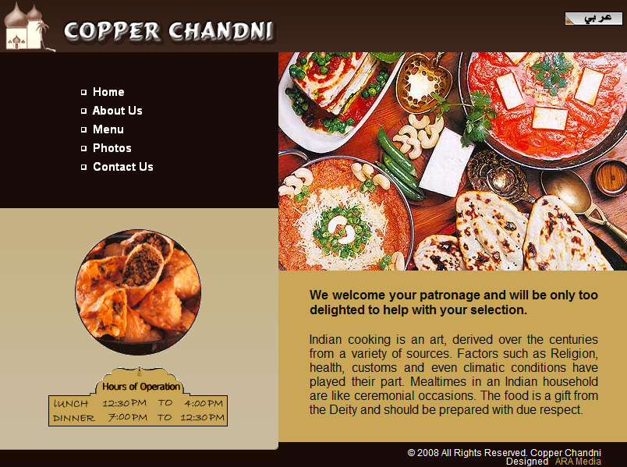
- This is the main page to Copper Chandni restaurant's website. Read it carefully and answer the following questions:
1-This restaurant serves which cuisine?
2- What are the factors which the restaurant tries to apply?
3- Do you find the image presented in the first page of the website attractive?

Now, Read the following information about the restaurant as written in their 'about us' page
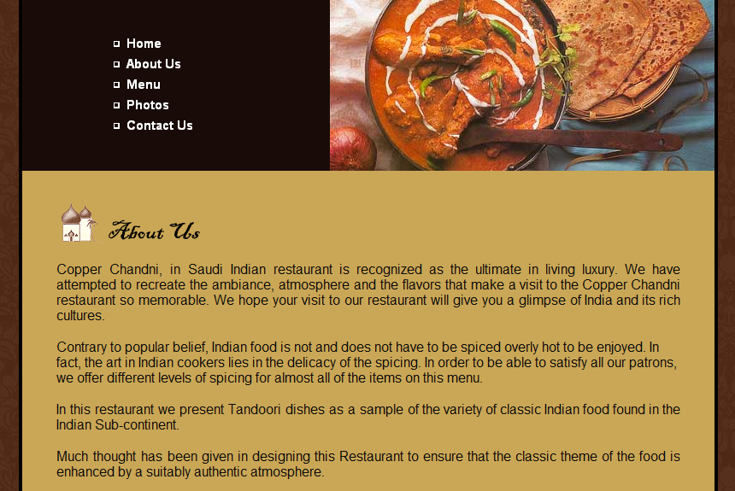

- Answer the following questions:
1- True or false:
A- Tandoori is a sample dish for Indian dishes. ( )
B- Indian food should be spicy and hot to be enjoyed ( )
C- 'Contrary to popular belief' means it is the same as what people usually think. ( )
2- Can you rearrange the first sentence to make it grammatically correct ?

Read the Menu to answer the following questions:
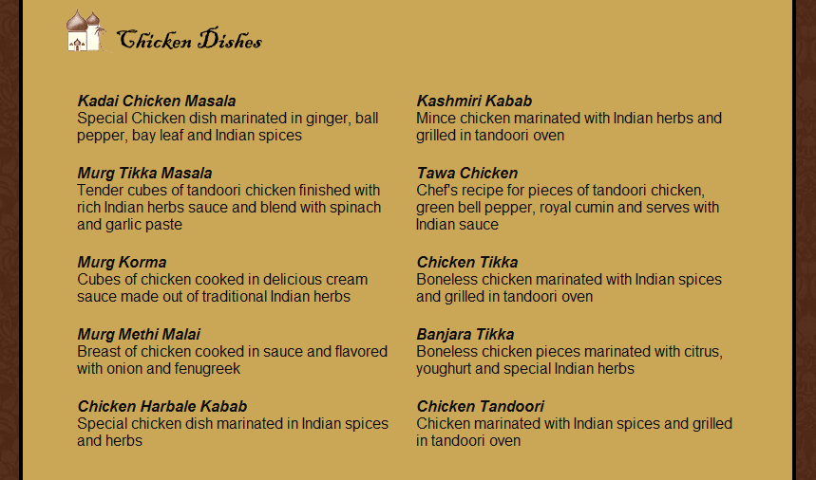

- Choose three of the dishes mentioned above to fill the chart with the ingredients for each dish:
Ingredients: |  |  |  |  | Name of the Dish:

The end..

